**Dialog class**

**Font Dialog**

Prompts the user to choose a font from among those installed on the local computer.

* Constructors: FontDialog
* Methods: Dispose, ShowDialog
* Properties: Color,Font,ShowColor

**Colour Dialog**

Represents a common dialog Box that displays available colors along with colors that enable the user to define custom colours.

* Constructors:ColorDialog
* Methods:Dispose,ShowDialog
* Properties:Color

**Open File Dialog**

Prompts the user to open a file

* Constructor: OpenFileDialog
* Methods: Dispose, OpenFile, ShowDialog
* Properties: FileName, Filter, InitialDirectory

**Save File Dialog**

Prompts the user to select a location for saving a file

* Constructors: SaveFileDialog
* Methods: Dispose, OpenFile, ShowDialog
* Properties: FileName, Filter, InitialDirectory

**Filters:** Some the filters files…

<filedialog Name> fd=new <filedialog>();

* fd.Filter = "Rich Text Files|*.rtf";
* fd.Filter = "All Word Documents|*.docx";
* fd.Filter = "Text Files|*.txt";
* fd.Filter = "All Files|*.*";

**Stream Writer**

Implements a text writer for writing characters to a stream in a particular encoding

* Constructors : StreamWriter(String), StreamWriter(String, Boolean)
* Methods : Close, Dispose ,Flush, Write, WriteLine
* Properties : BaseStream, NewLine

**Stream Reader**

Implements a text reader that reads characters from a byte stream in particular encoding.

* Constructors : StreamReader(String,Boolean)
* Methods : Close, Dispose, Read, ReadLine, ReadToEnd
* Properties : BaseStream, EndOfStream

**Program:**

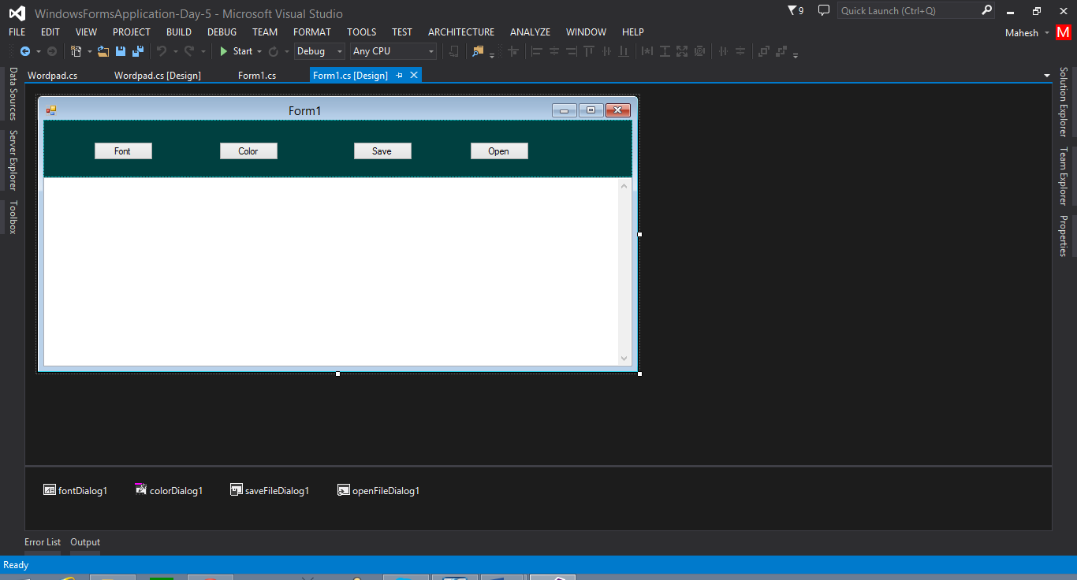

**Coding**

using System;

using System.Collections.Generic;

using System.ComponentModel;

using System.Data;

using System.Drawing;

using System.Linq;

using System.Text;

using System.Threading.Tasks;

using System.Windows.Forms;

using System.IO;

namespace WindowsFormsApplication_Day_5

{

public partial class Form1 : Form

{

public Form1()

{

InitializeComponent();

}

private void button1_Click(object sender, EventArgs e)

{

// font dialog

fontDialog1.ShowDialog();

textBox1.Font = fontDialog1.Font;

fontDialog1.Dispose();

}

private void button2_Click(object sender, EventArgs e)

{

// color dialog

colorDialog1.ShowDialog();

textBox1.ForeColor = colorDialog1.Color;

colorDialog1.Dispose();

}

private void button3_Click(object sender, EventArgs e)

{

// save dialog

// 1. filter

saveFileDialog1.Filter = "Text Documents|*.txt";

//2. open dialog

saveFileDialog1.ShowDialog();

//3. take the dialog file name

string filename = saveFileDialog1.FileName;

// 4. save file using sreamwriter

if(filename!="")

{

StreamWriter sw = new StreamWriter(filename);

sw.Write(textBox1.Text);

sw.Close();

}

//close dialog

saveFileDialog1.Dispose();

}

private void button4_Click(object sender, EventArgs e)

{

// open dialog

// 1.filter

openFileDialog1.Filter = "Text Documents | *.txt";

//2.open dialog

openFileDialog1.ShowDialog();

//3.select filename

string filename = openFileDialog1.FileName;

if(filename!="")

{

StreamReader sr = new StreamReader(filename);

textBox1.Text = sr.ReadToEnd();

sr.Close();

}

// close dialog

openFileDialog1.Dispose();

}

}

}

**Rich Text Box**

Represents a window richtextboxcontrol (similar to normal textbox having the features of loadfile, savefile)

* Constructors : RichTextBox
* Methods: Dispose, LoadFile, SaveFile
* Properties: MultiLine, SelectRtf, SelectedText

In wordpadcreate a file save the file as:”Welcome.rtf”

**Create WordPad**

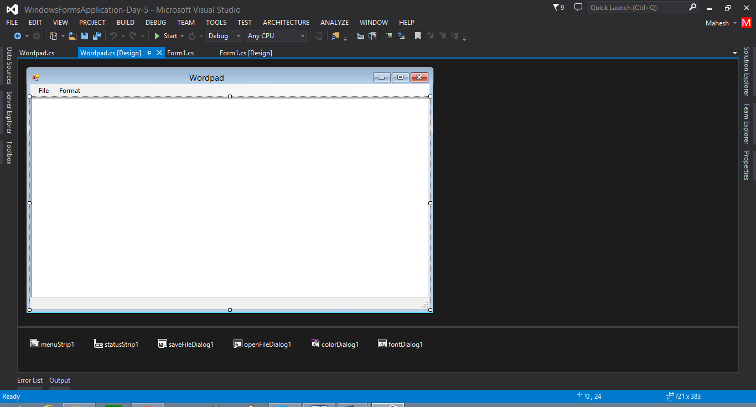

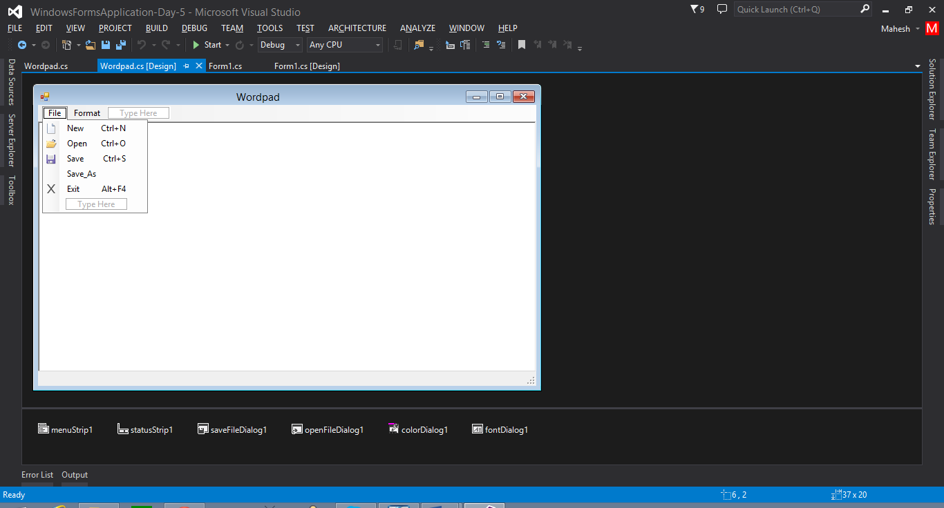

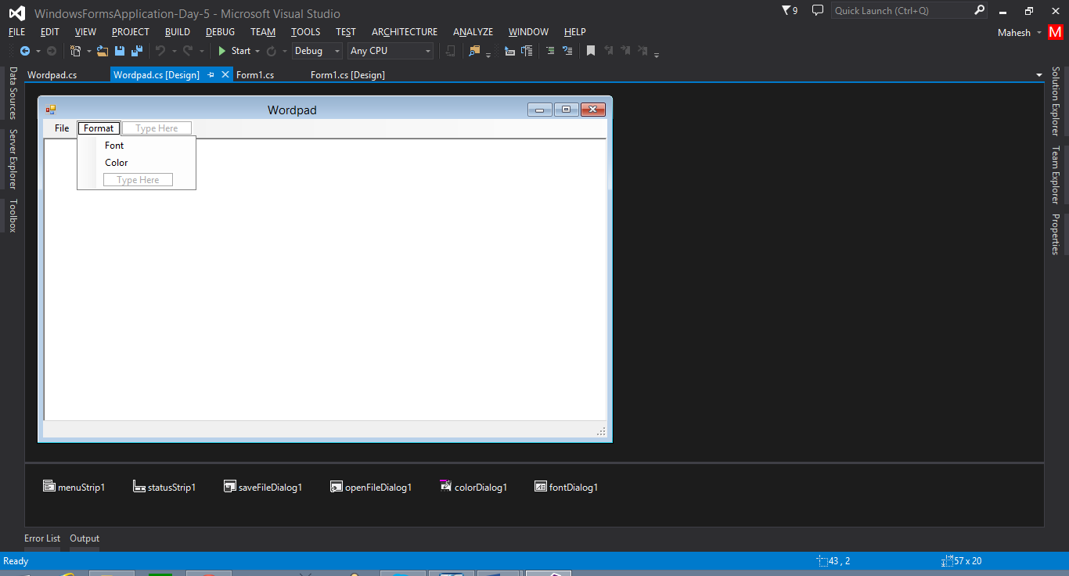

**Coding**

using System;

using System.Collections.Generic;

using System.ComponentModel;

using System.Data;

using System.Drawing;

using System.Linq;

using System.Text;

using System.Threading.Tasks;

using System.Windows.Forms;

namespace WindowsFormsApplication_Day_5

{

public partial class Wordpad : Form

{

// global variables

string filename;

// save as function

void saveas_file()

{

// filter

saveFileDialog1.Filter = "Rich Text Format | *.RTF";

// open dialog

saveFileDialog1.ShowDialog();

// take filename

filename = saveFileDialog1.FileName;

// save data

if(filename!="")

{

richTextBox1.SaveFile(filename);

}

saveFileDialog1.Dispose();

}

// save function

void save_File()

{

// check filename

if(filename!="")

{

richTextBox1.SaveFile(filename);

}

else

{

saveas_file();

}

}

// open function

void Open_File()

{

// filter

openFileDialog1.Filter = "Rich Text Format | *.RTF";

// open dialog

openFileDialog1.ShowDialog();

// filename

filename = openFileDialog1.FileName;

// read the data

if(filename!="")

{

richTextBox1.LoadFile(filename);

}

openFileDialog1.Dispose();

}

public Wordpad()

{

InitializeComponent();

}

private void newToolStripMenuItem_Click(object sender, EventArgs e)

{

if(richTextBox1.Text!="" && filename!="")

{

DialogResult res=MessageBox.Show(" Do u want save the file...", "Save", MessageBoxButtons.YesNoCancel, MessageBoxIcon.Question);

if(res.ToString()=="Yes")

{

save_File();

richTextBox1.Clear();

filename = "";

}

else if(res.ToString()=="No")

{

richTextBox1.Clear();

filename = "";

}

else

{

richTextBox1.Focus();

}

}

else

{

richTextBox1.Clear();

filename = "";

}

}

private void openToolStripMenuItem_Click(object sender, EventArgs e)

{

if (richTextBox1.Text != "" && filename != "")

{

DialogResult res = MessageBox.Show(" Do u want save the file...", "Save", MessageBoxButtons.YesNoCancel, MessageBoxIcon.Question);

if (res.ToString() == "Yes")

{

save_File();

Open_File();

}

else if (res.ToString() == "No")

{

Open_File();

}

else

{

richTextBox1.Focus();

}

}

else

{

Open_File();

}

}

private void saveToolStripMenuItem_Click(object sender, EventArgs e)

{

save_File();

}

private void saveAsToolStripMenuItem_Click(object sender, EventArgs e)

{

saveas_file();

}

private void exitToolStripMenuItem_Click(object sender, EventArgs e)

{

if (richTextBox1.Text != "" && filename != "")

{

DialogResult res = MessageBox.Show(" Do u want save the file...", "Save", MessageBoxButtons.YesNoCancel, MessageBoxIcon.Question);

if (res.ToString() == "Yes")

{

save_File();

Application.Exit();

}

else if (res.ToString() == "No")

{

Application.Exit();

}

else

{

richTextBox1.Focus();

}

}

else

{

Application.Exit();

}

}

private void fontToolStripMenuItem_Click(object sender, EventArgs e)

{

fontDialog1.ShowDialog();

richTextBox1.Font = fontDialog1.Font;

fontDialog1.Dispose();

}

private void colorToolStripMenuItem_Click(object sender, EventArgs e)

{

colorDialog1.ShowDialog();

richTextBox1.ForeColor = colorDialog1.Color;

colorDialog1.Dispose();

}

}

}

**Create Noted Pad using Textbox**

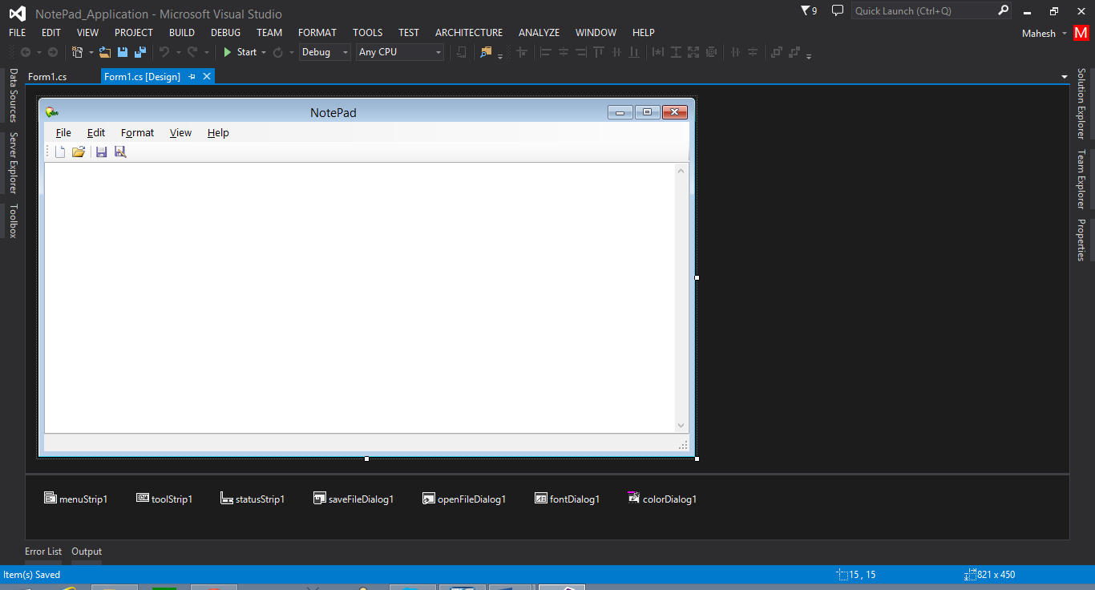

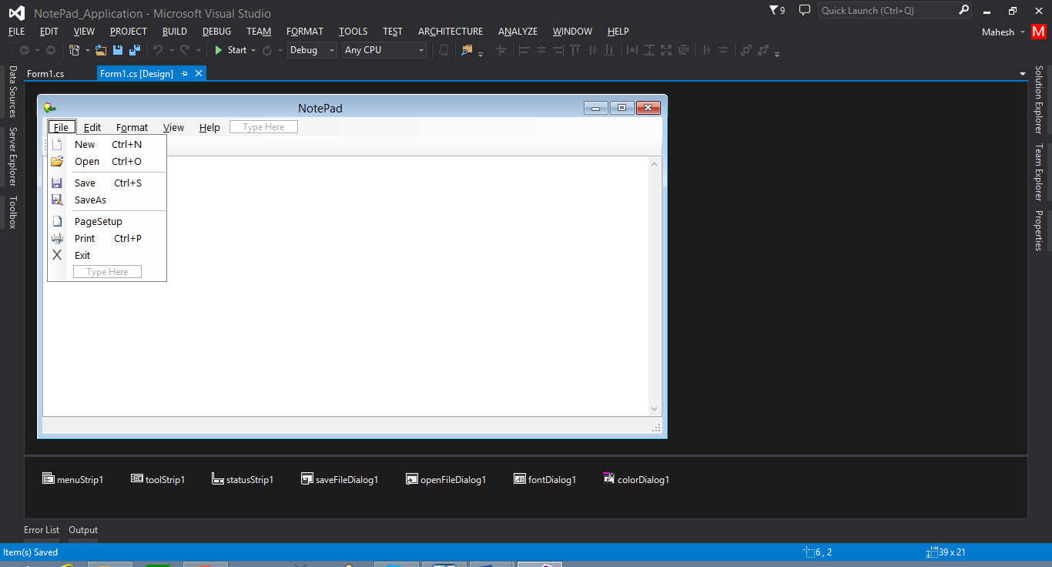

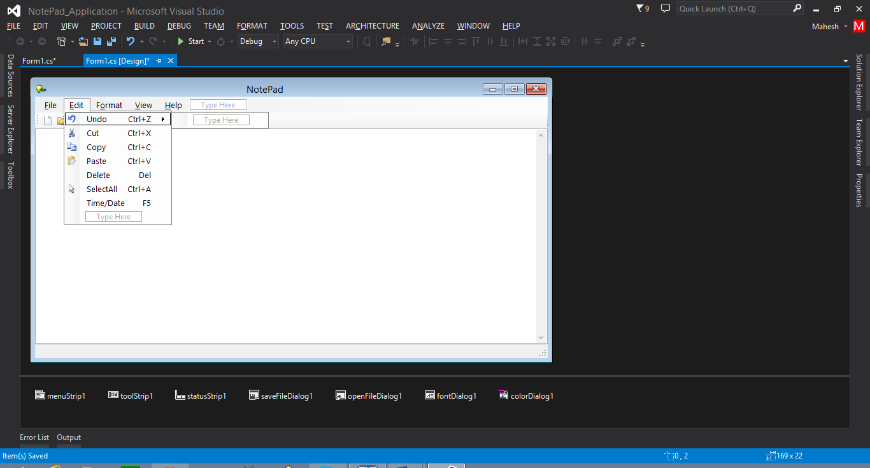

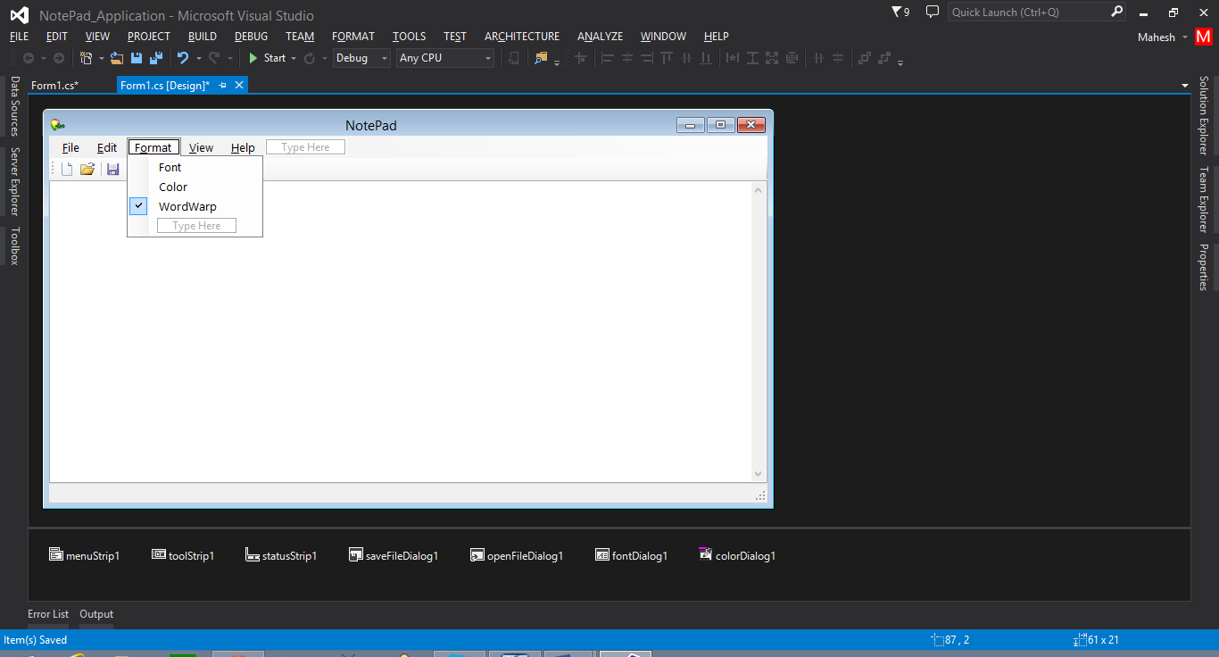

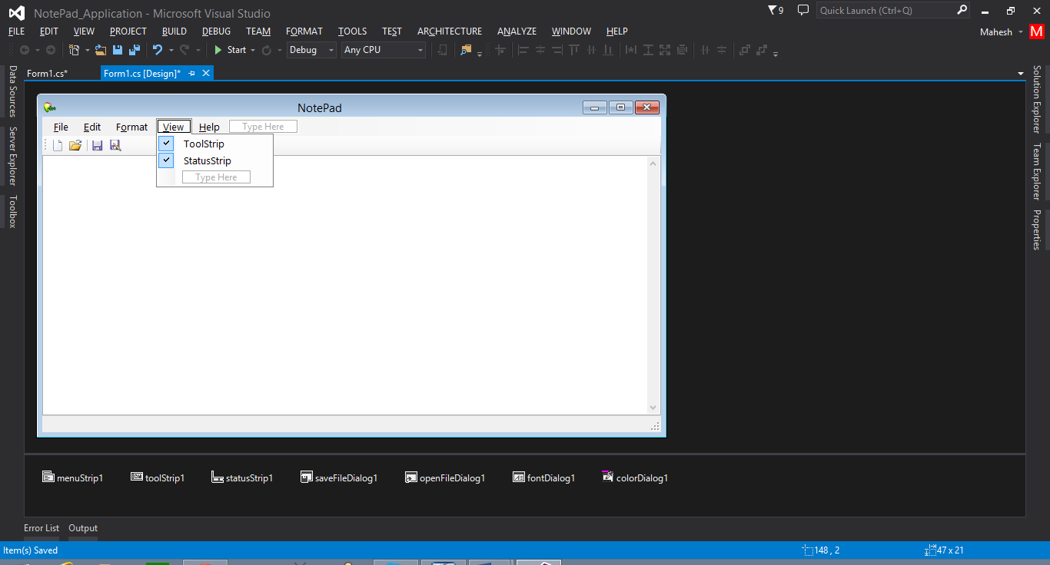

**Coding**

using System;

using System.Collections.Generic;

using System.ComponentModel;

using System.Data;

using System.Drawing;

using System.Linq;

using System.Text;

using System.Threading.Tasks;

using System.Windows.Forms;

using System.IO;

namespace NotePad_Application

{

public partial class Form1 : Form

{

// Declare File Name

string filename="";

// saveas

void saveas_Notepad()

{

// filter

saveFileDialog1.Filter = "Text Documents | *.txt";

// open dialog

saveFileDialog1.ShowDialog();

// take filename

filename = saveFileDialog1.FileName;

// save data

if (filename != "")

{

StreamWriter sw = new StreamWriter(filename);

sw.Write(textBox1.Text);

sw.Close();

}

saveFileDialog1.Dispose();

}

// save

void Save_Notepad()

{

// check filename

if (filename != "")

{

StreamWriter sw = new StreamWriter(filename);

sw.Write(textBox1.Text);

sw.Close();

}

else

{

saveas_Notepad();

}

}

// open

void Open_NotePad()

{

// filter

openFileDialog1.Filter = "Text Documents | *.txt";

// open dialog

openFileDialog1.ShowDialog();

// filename

filename = openFileDialog1.FileName;

// read the data

if (filename != "")

{

StreamReader sr = new StreamReader(filename);

textBox1.Text = sr.ReadToEnd();

sr.Close();

}

openFileDialog1.Dispose();

}

public Form1()

{

InitializeComponent();

}

private void helpToolStripMenuItem_Click(object sender, EventArgs e)

{

}

private void newToolStripMenuItem_Click(object sender, EventArgs e)

{

if(textBox1.Text!="" && filename!="")

{

DialogResult res = MessageBox.Show(" Do u want save the file...", "Save", MessageBoxButtons.YesNoCancel, MessageBoxIcon.Question);

if (res.ToString() == "Yes")

{

Save_Notepad();

textBox1.Clear();

textBox1.Focus();

filename = "";

}

else if (res.ToString() == "No")

{

textBox1.Clear();

textBox1.Focus();

filename = "";

}

else

{

textBox1.Focus();

}

}

else

{

textBox1.Clear();

textBox1.Focus();

}

}

private void openToolStripMenuItem_Click(object sender, EventArgs e)

{

if (textBox1.Text != "" && filename != "")

{

DialogResult res = MessageBox.Show(" Do u want save the file...", "Save", MessageBoxButtons.YesNoCancel, MessageBoxIcon.Question);

if (res.ToString() == "Yes")

{

Save_Notepad();

Open_NotePad();

}

else if (res.ToString() == "No")

{

Open_NotePad();

}

else

{

textBox1.Focus();

}

}

else

{

Open_NotePad();

}

}

private void saveToolStripMenuItem_Click(object sender, EventArgs e)

{

Save_Notepad();

}

private void saveAsToolStripMenuItem_Click(object sender, EventArgs e)

{

saveas_Notepad();

}

private void exitToolStripMenuItem_Click(object sender, EventArgs e)

{

if (textBox1.Text != "" && filename != "")

{

DialogResult res = MessageBox.Show(" Do u want save the file...", "Save", MessageBoxButtons.YesNoCancel, MessageBoxIcon.Question);

if (res.ToString() == "Yes")

{

Save_Notepad();

Application.Exit();

}

else if (res.ToString() == "No")

{

Application.Exit();

}

else

{

textBox1.Focus();

}

}

else

{

Application.Exit();

}

}

private void undoToolStripMenuItem_Click(object sender, EventArgs e)

{

textBox1.Undo();

}

private void cutToolStripMenuItem_Click(object sender, EventArgs e)

{

textBox1.Cut();

}

private void copyToolStripMenuItem_Click(object sender, EventArgs e)

{

textBox1.Copy();

}

private void pasteToolStripMenuItem_Click(object sender, EventArgs e)

{

textBox1.Paste();

}

private void deleteToolStripMenuItem_Click(object sender, EventArgs e)

{

textBox1.Cut();

}

private void selectAllToolStripMenuItem_Click(object sender, EventArgs e)

{

textBox1.SelectAll();

}

private void timeDateToolStripMenuItem_Click(object sender, EventArgs e)

{

textBox1.Text = textBox1.Text + "\n" + DateTime.Now.ToString();

}

private void fontToolStripMenuItem_Click(object sender, EventArgs e)

{

fontDialog1.ShowDialog();

textBox1.Font = fontDialog1.Font;

fontDialog1.Dispose();

}

private void colorToolStripMenuItem_Click(object sender, EventArgs e)

{

colorDialog1.ShowDialog();

textBox1.ForeColor = colorDialog1.Color;

colorDialog1.Dispose();

}

private void wordWarpToolStripMenuItem_Click(object sender, EventArgs e)

{

if(wordWarpToolStripMenuItem.Checked==true)

{

textBox1.WordWrap = true;

}

else

{

textBox1.WordWrap = false;

}

}

private void toolStripToolStripMenuItem_Click(object sender, EventArgs e)

{

if(toolStripToolStripMenuItem.Checked==true)

{

toolStrip1.Visible = true;

}

else

{

toolStrip1.Visible = false;

}

}

private void statusStripToolStripMenuItem_Click(object sender, EventArgs e)

{

if (statusStripToolStripMenuItem.Checked == true)

{

statusStrip1.Visible = true;

}

else

{

statusStrip1.Visible = false;

}

}

private void toolStripButton1_Click(object sender, EventArgs e)

{

if (textBox1.Text != "" && filename != "")

{

DialogResult res = MessageBox.Show(" Do u want save the file...", "Save", MessageBoxButtons.YesNoCancel, MessageBoxIcon.Question);

if (res.ToString() == "Yes")

{

Save_Notepad();

textBox1.Clear();

textBox1.Focus();

filename = "";

}

else if (res.ToString() == "No")

{

textBox1.Clear();

textBox1.Focus();

filename = "";

}

else

{

textBox1.Focus();

}

}

else

{

textBox1.Clear();

textBox1.Focus();

}

}

private void toolStripButton2_Click(object sender, EventArgs e)

{

if (textBox1.Text != "" && filename != "")

{

DialogResult res = MessageBox.Show(" Do u want save the file...", "Save", MessageBoxButtons.YesNoCancel, MessageBoxIcon.Question);

if (res.ToString() == "Yes")

{

Save_Notepad();

Open_NotePad();

}

else if (res.ToString() == "No")

{

Open_NotePad();

}

else

{

textBox1.Focus();

}

}

else

{

Open_NotePad();

}

}

private void toolStripButton3_Click(object sender, EventArgs e)

{

Save_Notepad();

}

private void toolStripButton4_Click(object sender, EventArgs e)

{

saveas_Notepad();

}

}

}